**PowerBI Analysis**

1.What are the top 5 contributing departments for the total sales?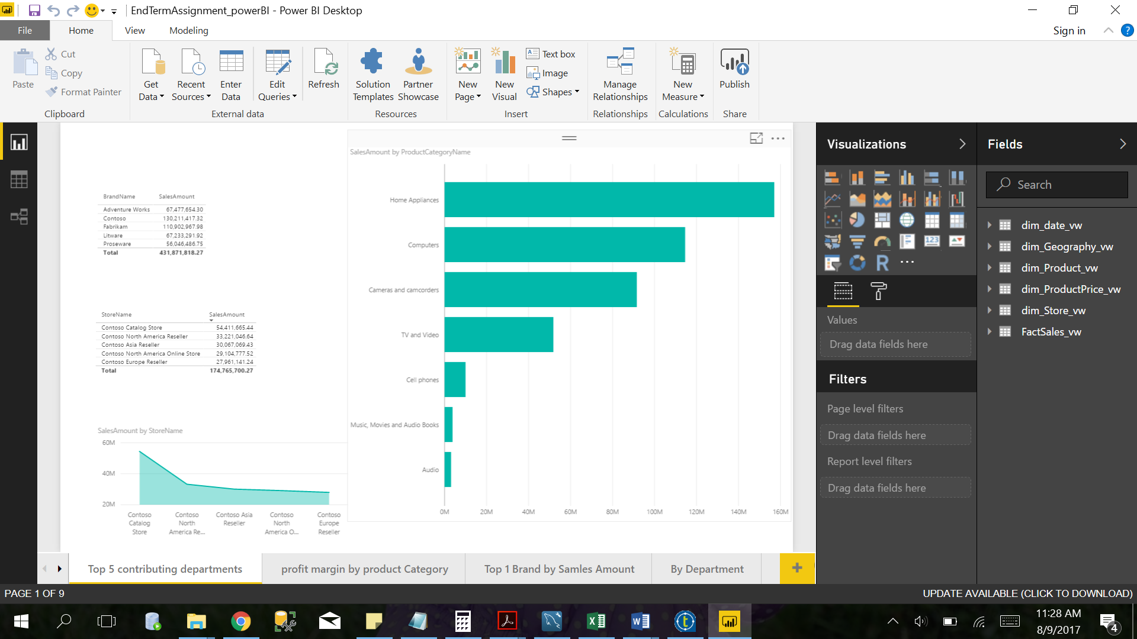

Figure : Top 5 contributing departments

2.How does the profit margin for each of these vary?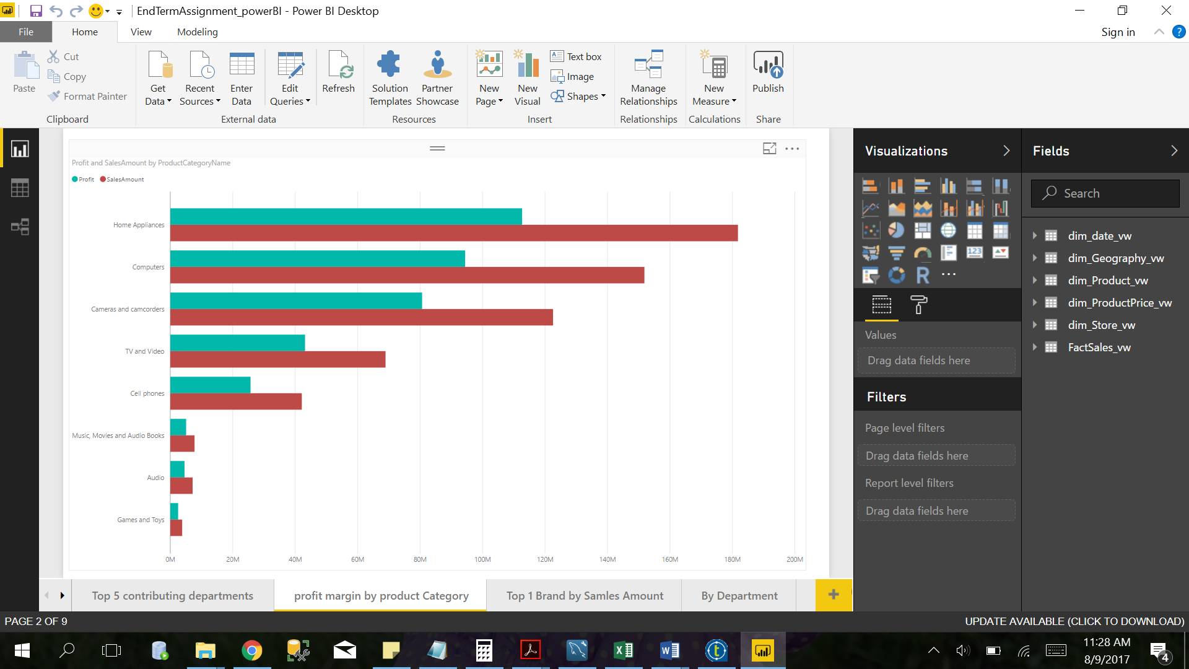

Figure : Profit margin by product category

3.How has the sales for the top department changed over the months in 2014?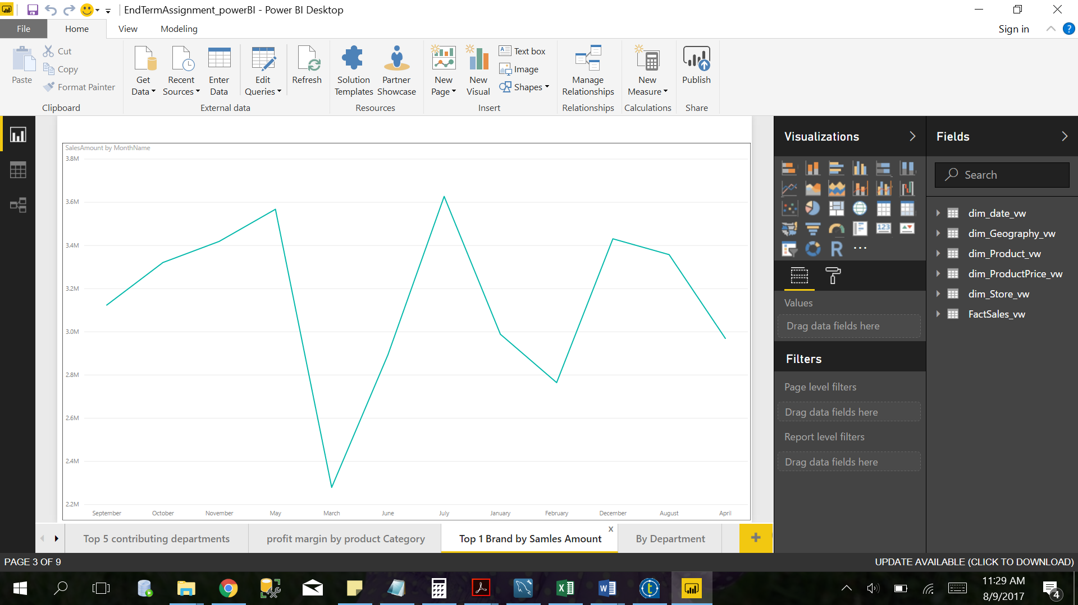

Figure : Top brand by sales amount

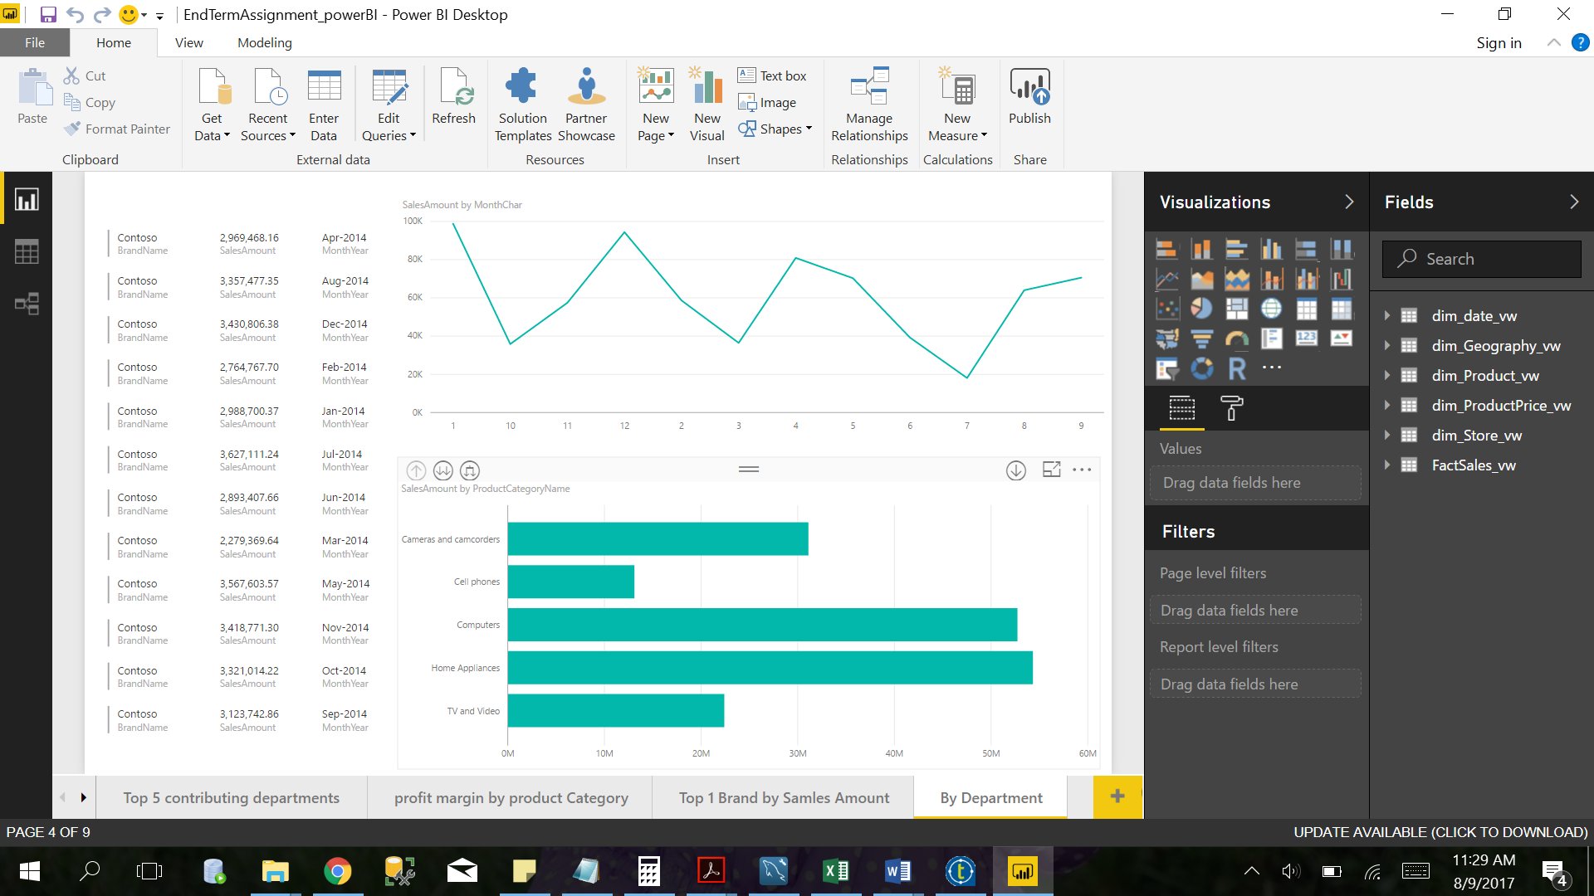

Figure : Top brand by department

4.Which department contributes to the maximum profit?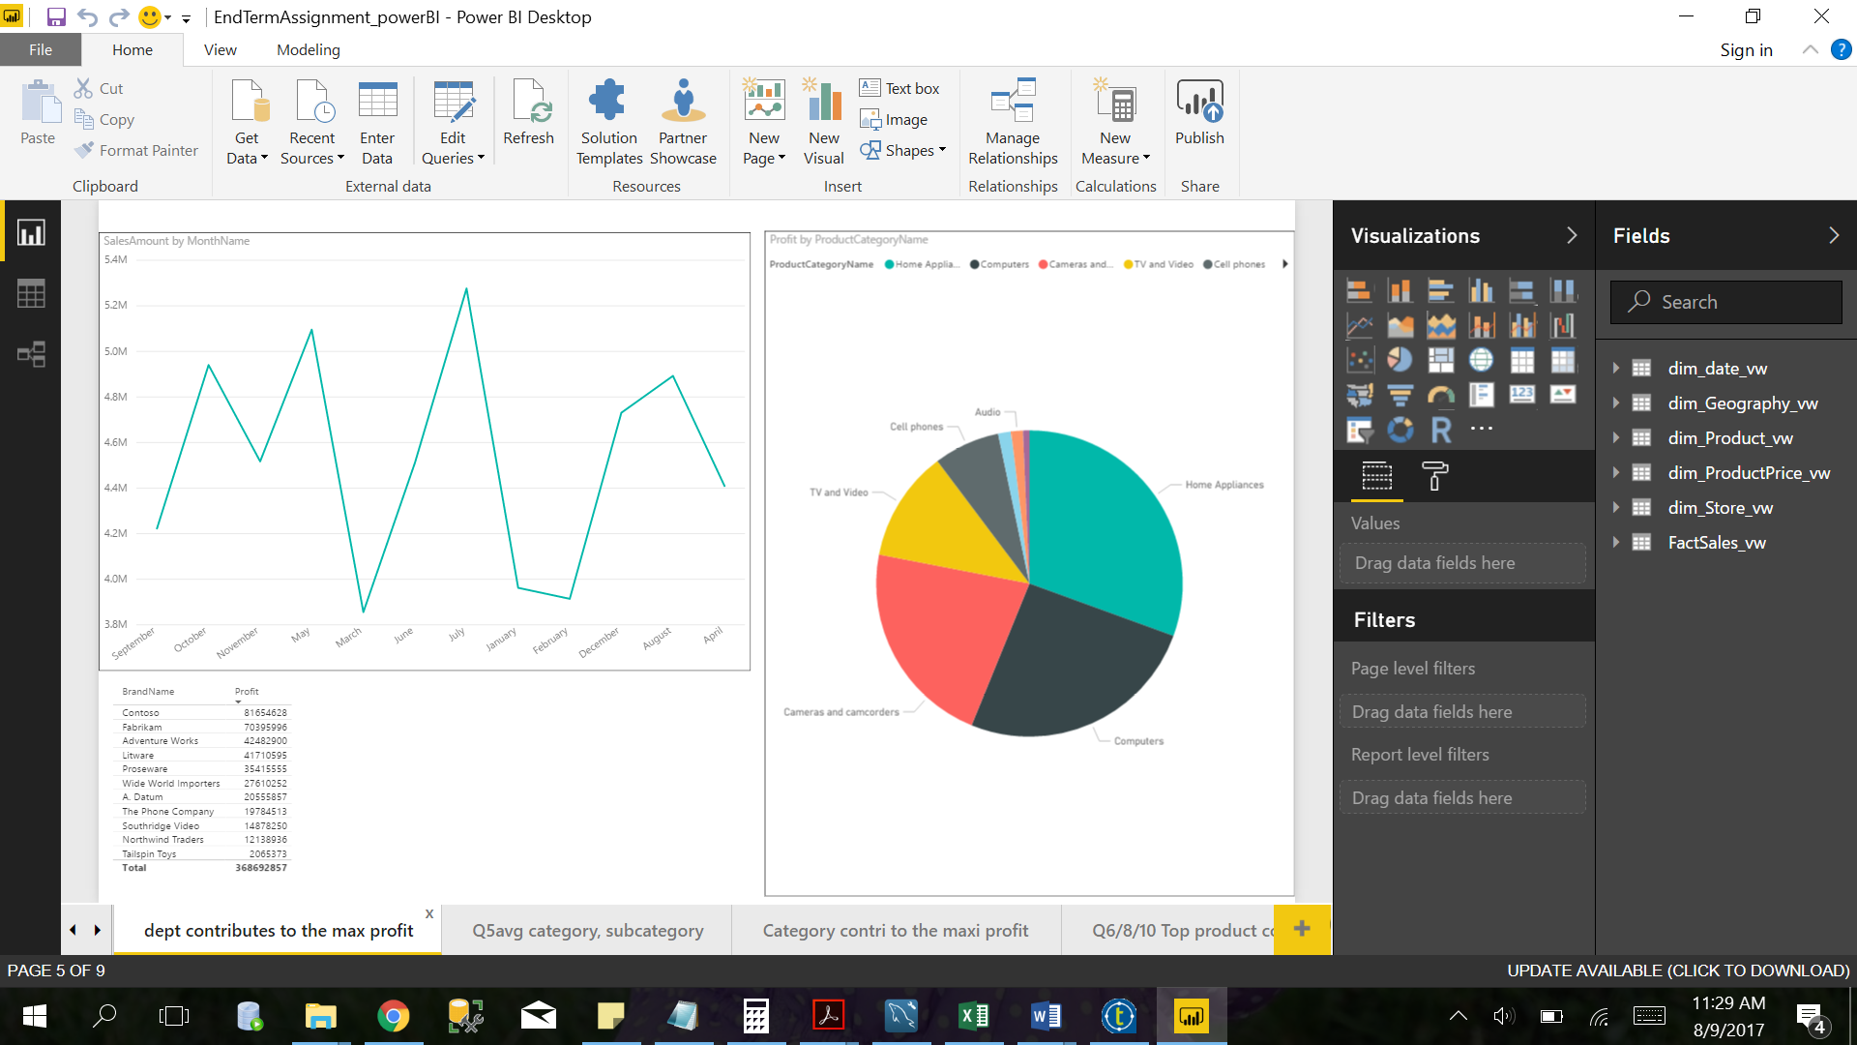

Figure : department contribution to profit

5.What is the average quantity of products bought in each category, subcategory?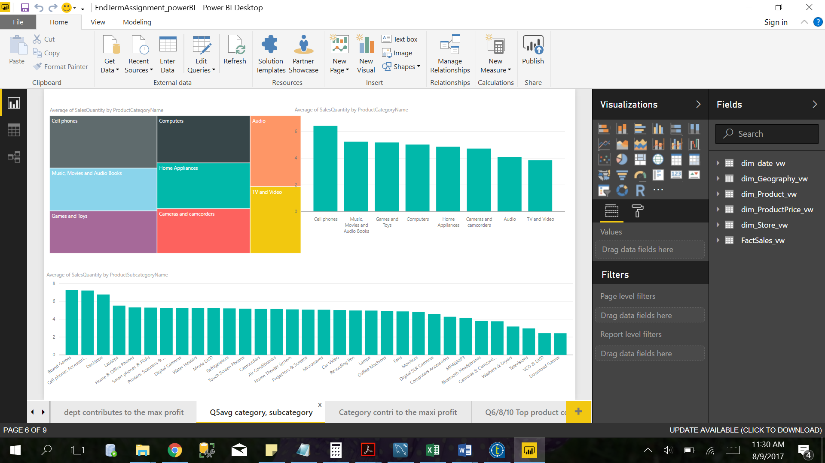

Figure : Average quantity of product bought, category-wise and sub category-wise

6.How much of the sales does the top product contribute to its dept, category & sub category?

8.Which department has the most expensive products? How many of these products are sold every year?

10.How does sales of the cheapest department vary across states?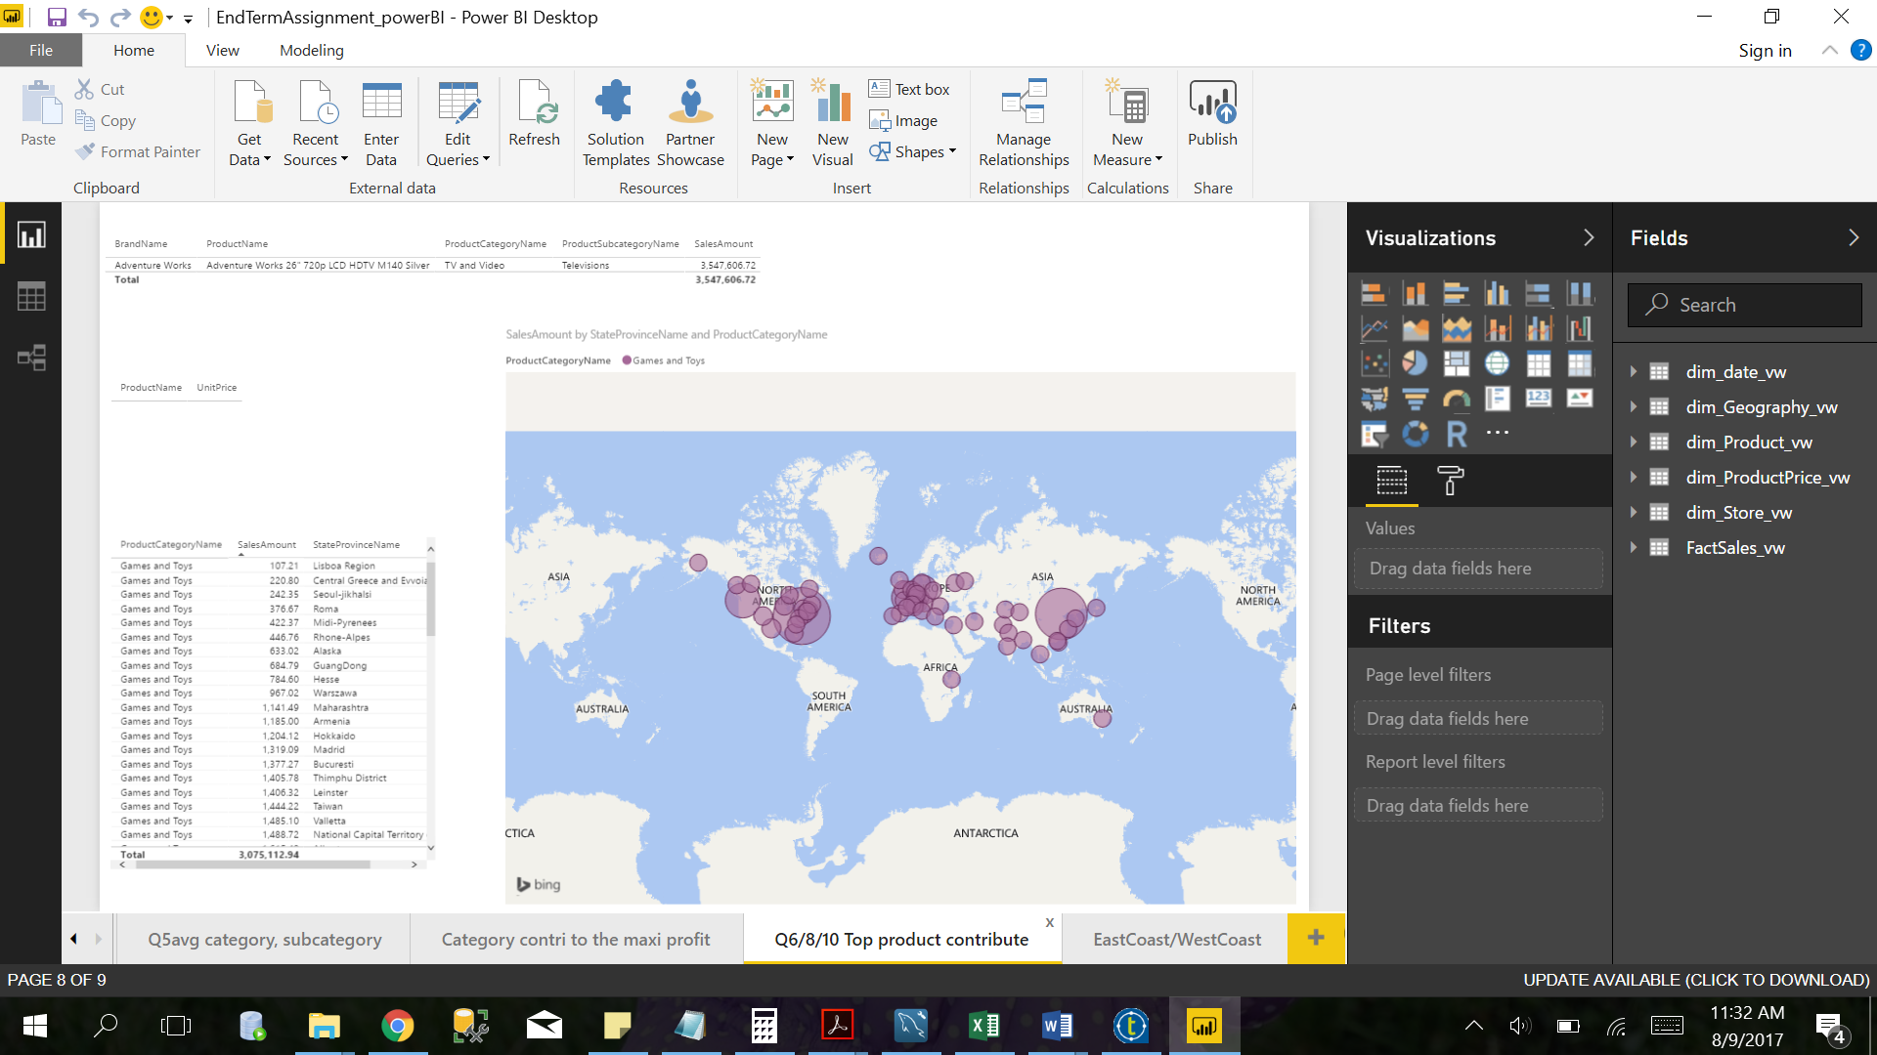

Figure : Top product contributions

7.Which department has the best sales in the east coast? Is it the same on the west coast? (You can select what states you want to categorize as east & west )

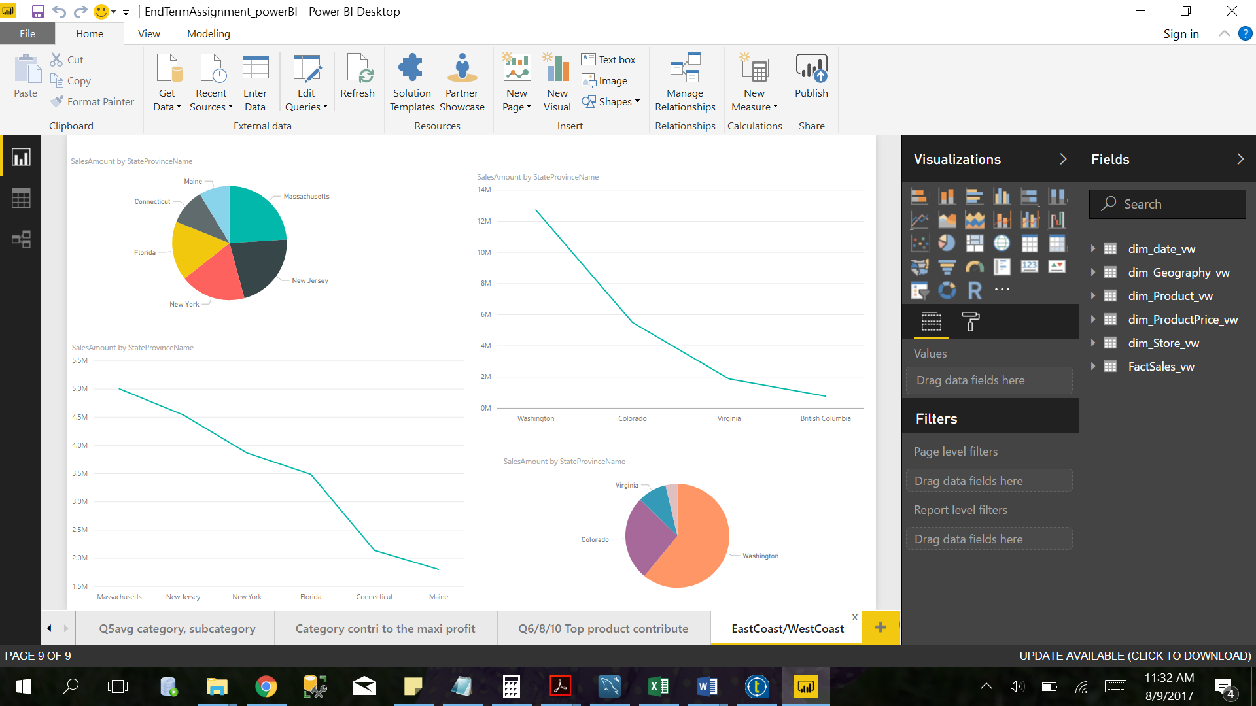

Figure : East coast sales vs West coast sales

9.What category contributes to the maximum profit earned each year?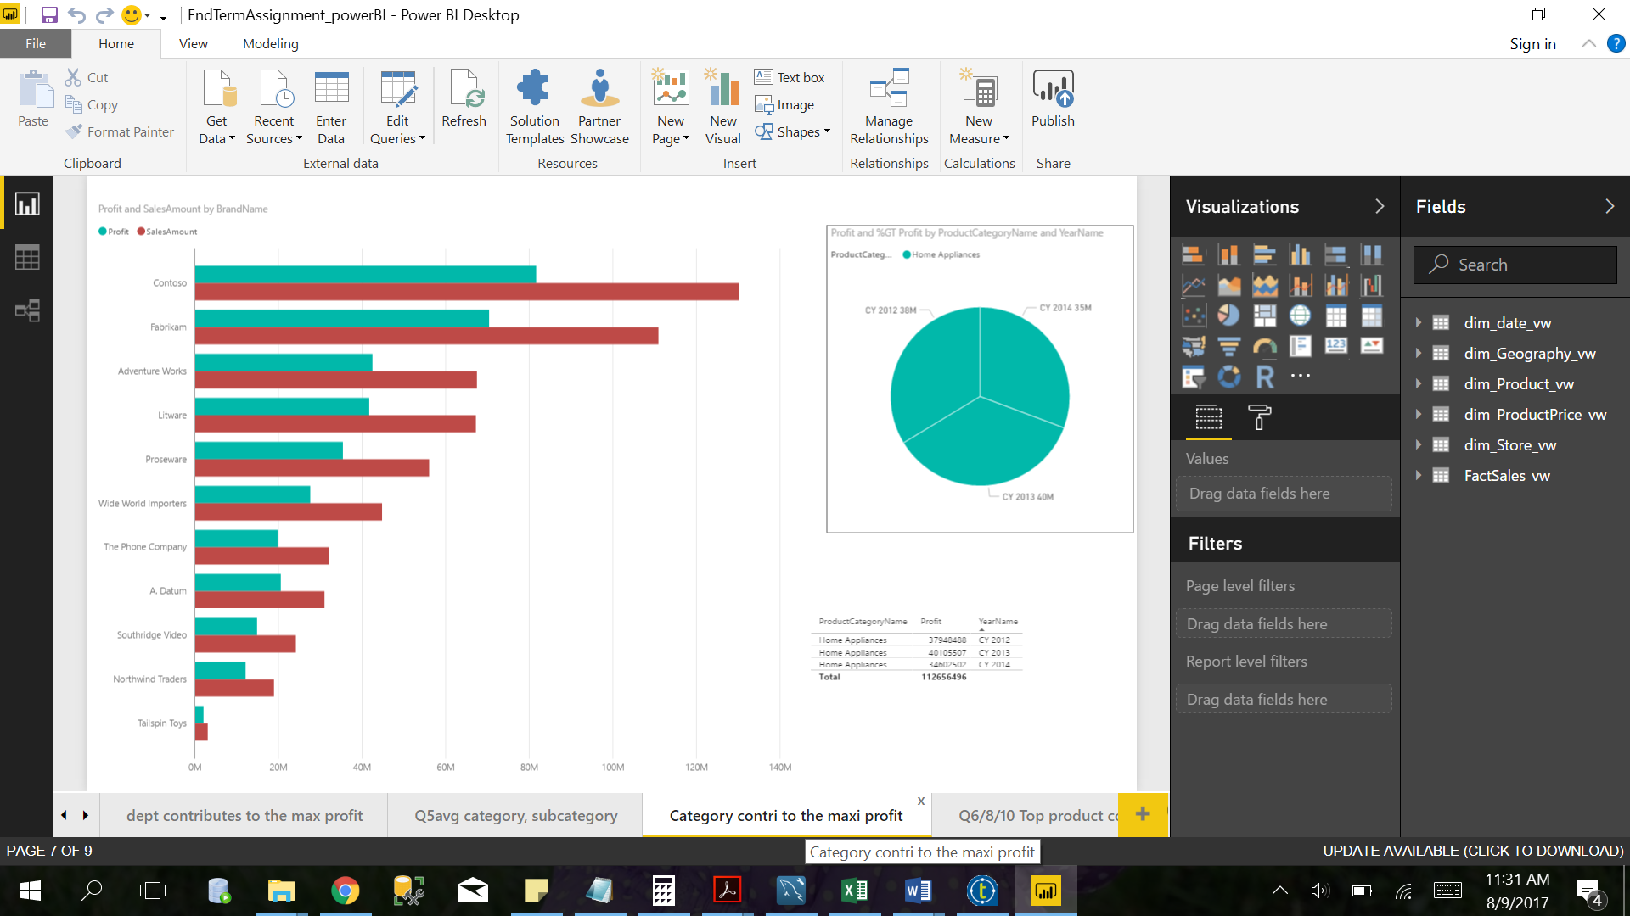

Figure : Category wise contribution to profit